GES Realization via Existing Specifications
Andrew Grimshaw
V-2, May 15, 2009

Claim 1
Requirements 1
Non-Functional aspects 3
Background on existing specifications 4
Meeting the Requirements 6
OGSA- BES. 7
JSDL 8
Activity Endpoint profile 9
Requirements Redux 9

Claim
The requirements in the GES information document dated April 29, 2009, can be realized using existing specifications with minor modifications. Specifically JSDL, OGSA-BES, RNS, OGSA-ByteIO, WS-Notification, and OGSA-WSRF-BP. The above do not address the security aspects as those are being addressed elsewhere.

Changes from V-1. During the teleconference on May 13th several misunderstandings of the GES Strawman document were uncovered that require an update to the “Requirements” section. Further, some underspecified aspects of the same document, e.g., what “parallel application” exactly means, were found. This version attempts to address the issues raised.

Requirements
Lets start by looking at the requirements (the MUSTs) from the April 29, 2009 GES document.
Terms: (as I understand their use in the document)
“Session directory”, a.k.a. the “sandbox file system’. This is the execution directory the activity will use. It can also be used as the place to stage files in and out, and possibly monitor the execution of the application.
I grouped requirements by whether I thought of them as execution container requirements, create activity requirements, state change requirements, data staging, or activity endpoint requirements. It is pretty arbitrary and they could be re-ordered. It allows me to number them though, which I will use later.
Container (C)
- MUST provide access to attributes/meta data that describe the container using GLUE2. (V-2 note: The appropriate sections of the XML rendering of GLUE2 need to be indentified.)
- MUST be able to list activity EPRs, for example post-facto if the client crashes, (as modified by access control policy)
“Create Activity” (CA)
- MUST be able to start activity in Pending state (implies pending state)
- MUST provide mechanism to interact with a “session directory” while activity exists. (V-2 note: This subsumes requirements A5 and DS1).
- MUST throw a fault if an invalid document is submitted
- MUST throw a fault if it is unable to create the activity.
- MUST be able to accept multiple creates, i.e., a vector of creates, and return a vector of responses.
- SHOULD support notification on activity state change
- MUST support GLUE2 schema for resource description
- MUST support service directed staging in and out of data.
- SHOULD support parallel jobs. (Does this mean all containers MUST support parallel jobs? V-2 note: During the teleconference two things became clear: not all GES endpoints must support parallel jobs, and at this point we are not talking about cross-GES resource parallel jobs. In other words, parallelism would be internal to the GES resource via perhaps MPI.))
- MUST (V-2 note: defaults as SHOULD make no sense) start in RUNNING/READY by default
“Change State” (CS)
- MUST support vector set activity state. (I would prefer an explicit list of state transitions that MUST be supported). (V-2 note: First, vector added. Second, the alternative of vector kill, vector suspend, vector resume, were discussed. A clear consensus did not emerge.) Note that this requirement subsumes A4.
- MUST support additional states, PENDING and PURGED. (V-2 note: Consensus that PURGED as a state makes no sense – the activity will be gone!)
Activity MUSTs (A)
- The state standard state model MUST be supported, e.g., BES state-model updated.
- MUST be possible to monitor (poll) the state of the activity
- MUST provide on request additional detail on the state, e.g., text strings indicating while the activity failed.
- MUST be possible to perform state transitions
- MUST provide a means to stage-in/out under client control
Data Staging (DS)
- MUST be able to transfer data in/out of the session directory during activity lifetime at the discretion of the client (or client delegates).
- MUST support the following protocols (not defined in the document, added by Grimshaw to start discussion): HTTP(S), scp, gridftp, mailto, RNS/ByteIO

Non-Functional aspects
The April 29 document also has a number of “SHOULD” elements, as well as some prescriptive suggestions for meeting the requirements.
Before I launch into how we can meet the requirements without inventing a whole new specification let me address one of the “non-functional” requirements in the April 29 GES document. On page 8 it states
“Ideally, the GES specification should be as much self-contained as possible, so that implementers can refer to the GES document only.”
I could not disagree more. The result will be a huge specification for which code must be written just to access the endpoint. No reuse, conceptual or otherwise is possible. This basically says no WS-Addressing, no WS-Security*, no XML, no SOAP, no anything. Instead we should re-invent the wheel completely.
I would argue instead that we should target as small a specification as possible and attempt to use existing specifications and mechanisms when it makes sense. Why go through the pain of working out every detail if someone has done if for us. Further, by choosing to use small, compos able specifications we create a type structure that can be more easily expanded in the future without breaking existing code.
“Perfection is achieved, not when there is nothing more to add, but when there is nothing left to take away.”
Antoine de Saint-Exupery
Finally, I do no know the details of the GLUE V2 specifications. I do now we will need to make a concrete XML version – or use an existing one if the rest of the team is aware of one.
From GFD.147,
“In this document, we present a conceptual information model for Grid entities described using natural language and enriched with a graphical representation using UML Class Diagrams. As a conceptual model, it is designed to be independent from the concrete data models adopted for its implementation. Rendering to concrete data models such XML Schema, LDAP Schema and SQL are provided in a separate document. From the semantic viewpoint, the concrete data models SHOULD represent the same concepts and relationships of the conceptual information model; nevertheless they MAY contain simplifications targeted at improving query performance or other aspects of interest."
Further, I assume there is a particular subset of the GLUE V2 that is of interest in this use case. I would hope that someone more familiar with GLUE V2 could separate that out.

Background on existing specifications
WS-Addressing defines an XML data structure called the end point reference (EPR) that encapsulates the information the client needs to message a service. The EPR includes a network protocol and address, an extensible metadata section to convey information such as security policy, and an opaque section for session/resource identifiers.
WS-Naming profiles WS-Addressing to provide identities and name rebinding. An optional EPR metadata element called end point identifier (EPI) is a URI that is unique in space and time. Clients can compare the EPIs contained in two or more EPRs. If the EPIs are the same, the EPRs are said to point to the same entity. The semantics of the underlying service determine sameness. If the EPIs are different, nothing can be inferred.
We may want to use WS-Naming for the ability to uniquely identify and compare jobs. We use them in accounting records.
OGSA-WSRF-BP provides mechanism to discover properties or attributes of grid resources or services, for example, the port-types, security mechanisms, and the provenance of data. . The OGSA WS-RF Base Profile addresses selected WSRF-RP specifications including the operation getResourceProperties, which returns an XML document with the metadata associated with a resource.
JSDL (Job Submission Description Language) documents are XML documents that describe a job: the resource requirements such as memory, number and type of CPUs, supported libraries, etc.; the input and output files, where they can be found, file access protocols to be used when staging data in and out; and the parameters to be passed to the application. If the application is not installed for a particular execution environment it must first be installed. Often this is accomplished by staging-in the application as well as the input data files. JSDL files are given to execution services to execute the described job.
OGSA-BES (Basic Execution Services) is a simple interface for creating new jobs, monitoring them, and managing their lifetime in addition to providing information useful for making scheduling decisions. On top of the JSDL and OGSA-BES specifications the HPC Profile Group inside the OGF has defined a number of specifications and profiles on existing specifications which further aide in interoperability.
Note that an important philosophical decision was made (after much arguing) that all operations on activities would be via the containing BES resource – not by making explicit calls on the activity. In other words no operations could take place directly on the activity. There was a great deal of debate about this. I’m going to assume that this decision is open again. If it is not, then everything I describe with respect to activities can be done the old way – albeit awkwardly.
HPC-BP (High Performance Computing Basic Profile) defines a simplified Application element which can be used inside of JSDL documents to more easily annotate how a sequential application should be run (what the executable is called, what the arguments are for the command line, etc.).
HPC-BP FSE (File-Staging Extensions) expands on the normal JSDL Data Staging elements to standardize on data staging protocols that can be used to copy data in and out of an application run. They profile how to pass security tokens for scp and ftp, gridftp.
RNS (Resource Namespace Service). RNS provides a basic directory service, mapping strings (paths) to WS-Addressing EPRs. RNS has functions to list, insert, and delete entries.
Note that RNS is an interface … it can be supported by many different types of resources to provide a standard way to interact with non-functional aspects of the resources. For example, nearly every Genesis II grid resource available to the user exists as a named path in a grid-wide RNS space (this includes everything from file and directories to execution containers, queues, running applications and even non-grid web sites).
Because RNS paths can refer to any relevant grid (or web) service, one achieves a hierarchical (or directed graph, filesystem-like) organization by allowing a named mapping inside an RNS resource to indicate another RNS resource (in much the same way as an entry inside a filesystem’s directory may be another filesystem directory). A distributed namespace emerges which, along with human organizational conventions, provides a complete and familiar picture to the end user. Despite the fact that the directory structure implied exists in a distributed grid that could span computers and countries, the familiarity of the file system view makes it easier for the end user to learn and navigate the new environment.
A good example of how this could be used is found in “Overview of the NorduGrid Information System”, Balazs Konya, 3rd NorduGrid Workshop, 23 May, 2002, Helsinki.

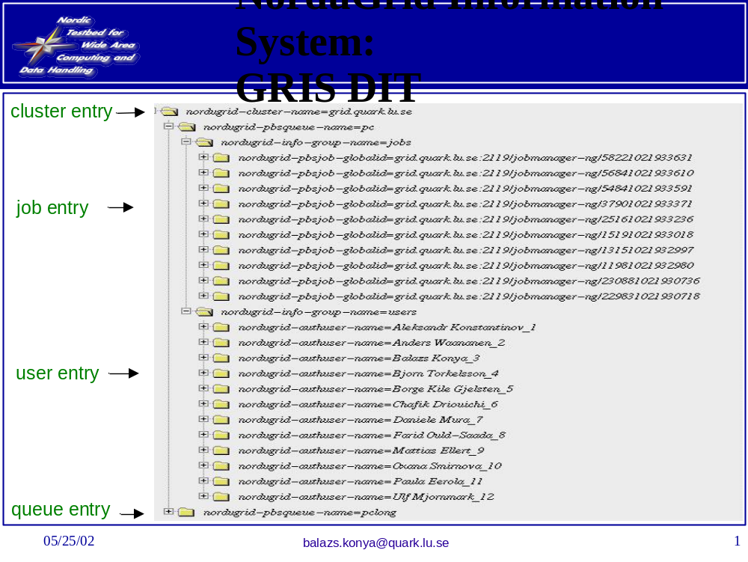
Here we can see that clusters, queues, and jobs are each viewed as directory entries that can be entered to fine a high level of detail. The directory paradigm is quite familiar to users, and when mapped into a file system using FUSE can be manipulated by shell scripts.
ByteIO. The ByteIO specification completes the picture of a distributed file system for the user. This specification describes a standard way of handling the transfer of data associated with grid endpoints, e.g., reading and writing. ByteIO has two separate port-types: random access and streamable. ByteIO is not limited to presenting file information, despite its intentional design as a file-like resource. Implementers may choose to use ByteIO to present a file-like interface to any source or sink of data.

Meeting the Requirements
Below I start with modifications to the specifications (if any) that I propose. Then I will show how each requirement can be met with the resulting profile. The basic idea is simple, OGSA-BES resources are modified slightly, and they support both the BES and RNS porttypes. The EPR’s they return also support the RNS porttype, profiled as I will show later.

OGSA- BES.
Clearly to meet the GLUE requirement will require a new BES 1.1 that modifies the information model to be compliant with GLUE. The subset of GLUE will need to be indentified in either case (new spec or reuse existing specs).
Secondly, functions that operate on activities will need to be turned into “vector” operations. The primary complexity is how to handle faults. In other contexts this has been handled by returning a list of result elements, with success or failure indicated in the result elements. For example, createActivity, change state, etc.
Third, the state model will need to be changed back to what it was (V27 in this case). These are completely described in the BES document, including how state composition is described in XML. There will be no need to re-do the effort. The state model and profile on the model to meet our requirements are shown below.
Pending
Running
Finished
Canceled
Failed
TerminateActivity request
System error/failure event
Successful termination of activity
I further suggest that we go ahead and profile both staging and suspend/resume.
Pending
Running:
Stage-in
Finished
Canceled
Failed
Running:
Executing
Running:
Stage-out

Pending
Running:
Stage-in
Finished
Canceled
Failed
Running:
Executing
Running:
Stage-out

Fourth, BES endpoints MUST accept a notification request in the JSDL. I would suggest WS-Notification.
Fifth, BES endpoints MUST implement the RNS interface (list, delete, insert). They MAY throw faults on insert/delete. The list operation will return a list of all of the activities in the container, or possibly sub-services (more later).
NB: This next bit is a profile action, not a specification.
Each BES resource would support both the BES and RNS porttypes. The BES porttype we know. The RNS list operation would return a list of directories (RNS services)
Submission-point
Jobs
All
Pending
Running
Finished
Mine
Pending
Running
Finished
Summary – a text file that gives some sort of summary of the status of the BES
Information – perhaps map the XML somehow – this is less clear.
Sixth. V-2, createActivity will need to take an additional optional parameter, whether the activity should start in PENDING.

JSDL
Start_pending element – V-2 note: Disagreement – this is not an attribute of the job, but additional information you pass to the create activity.
Subscribe to state change element
Optional “Must support” elements
Access to session directory
Grid file system
Modify information model to match GLUE 2

Activity Endpoint profile
Resource EPR’s returned by createActivity would support the RNS porttype with the following pre-determined profiled entries:
Session_dir
Files
Stderr - a streamable byteio
Stdout – a streamable byteio
Stdin – a streamable byteio
Status – a byteio file that can be read
Control-file – a byteio that can be used to send signals to the job
Proc-mem – a byteio file that provides access to the memory of sequential processes, so that debuggers can be attached
Grid_ftp_endpoint – (EPR is a degenerate and contains only the IRI of the gridftp endpoint).

If you wanted other file transfer mechanisms, then put the URI’s in degenerate EPR’s and put them in the RNS directory with some other name.
I would recommend that it support explicit methods to move to particular states – not between arbitrary states. For example:
Start(): transitions the activity from pending to running
Kill(): with malice towards none ☺ moves the activity to cancelled.
Note that purge can be accomplished by killing the job and removing all of the files in the session_dir.

Requirements Redux
Container (C)
- MUST provide access to attributes/meta data that describe the container using GLUE2

Satisfied by modifying the BES specification to use GLUE 2.

- MUST be able to list activity EPRs, for example post-facto if the client crashes, (as modified by access control policy)

Satisfied using RNS.list on BES container (resource)

“Create Activity” (CA)
- MUST be able to start activity in Pending state (implies pending state)

Satisfied by change to JSDL and change to BES implementation.

- MUST provide mechanism to interact with a “session directory” while activity exists

Satisfied by activity RNS.list on activity/session_directory. The client can then directly create/read/update/delete files in the session using bytio/RNS operations, or using RNS to find the EPR of a gridftp endpoint.

- MUST throw a fault if an invalid document is submitted

Satisfied by current specification

- MUST throw a fault if it is unable to create the activity.

Satisfied by current specification

- MUST be able to accept multiple creates, i.e., a vector of creates, and return a vector of responses.

Satisfied by proposed extensions to BES specification

- SHOULD support notification on activity state change

Satisfied by additional JSDL element (that if a BES cannot support, it will throw a fault)

- MUST support GLUE2 schema for resource description

Satisfied by changes to specifications.

- MUST support service directed staging in and out of data.

Satisfied by HPC-FSE.

- MUST support parallel jobs. (Does this mean all containers MUST support parallel jobs?)

Satisfied by JSDL SPMD profile

- SHOULD start in RUNNING/READY by default

Satisfied by current specification. Starting in pending requires the use of the new JSDL element.

“Change State” (CS)
- MUST be possible to activity status. (I would prefer an explicit list of state transitions that MUST be supported).

Satisfied by explicit transitions in activity porttype, start, kill.

- MUST support additional states, PENDING and PURGED.

Satisfied by changes in BES spec in the case of pending. No purged state needed given changes in activity porttype.

Activity MUSTs (A)
- The state standard state model MUST be supported, e.g., BES state-model updated.

Satisfied by BES base model combined with mandated profiled states.

- MUST be possible to monitor (poll) the state of the activity

Satisfied by activity/status file and the BES getactivitystatus

- MUST provide on request additional detail on the state, e.g., text strings indicating while the activity failed.

Satisfied by activity/status file

- MUST be possible to perform state transitions

Satisfied by activity start, kill

- MUST provide a means to stage-in/out under client control

Satisfied by pending along with activity/session_dir and/or activity/grid_ftp

Data Staging (DS)
- MUST be able to transfer data in/out of the session directory during activity lifetime at the discretion of the client (or client delegates).

Satisfied by activity/session_dir and/or activity/grid_ftp

- MUST support the following protocols (not defined in the document, added by Grimshaw to start discussion): HTTP(S), scp, gridftp, mailto, RNS/ByteIO

Satisfied by HPC-FSE.

